**ASSIGNMENTS**

**DIGITAL MARKETING**

**NAME** : KAVIYA S

**DEPARTMENT** : COMPUTER SCIENCE AND

ENGINEERING

**COLLEGE** : DHANALAKSHMI SRINIVASAN

: INSTITUTE OF TECHNOLOGY

**NAANMUDHALVAN**

**COURSE** : DIGITAL MARKETING

**NM ID** :46F70892EEC01EBBF1D458DD8014ECD9

ASSIGNMENTS ON DIGITAL MARKETING

1.Create a blog or website using Blogspot and WordPress.

Customize the theme design and post new article with

500 words.

[https://mehendistylish.blogspot.com/2023/08/mehendi-style_23.html](ASSIGNMENTS.docx)

<https://kaviyasrinivasan42781.wordpress.com/>

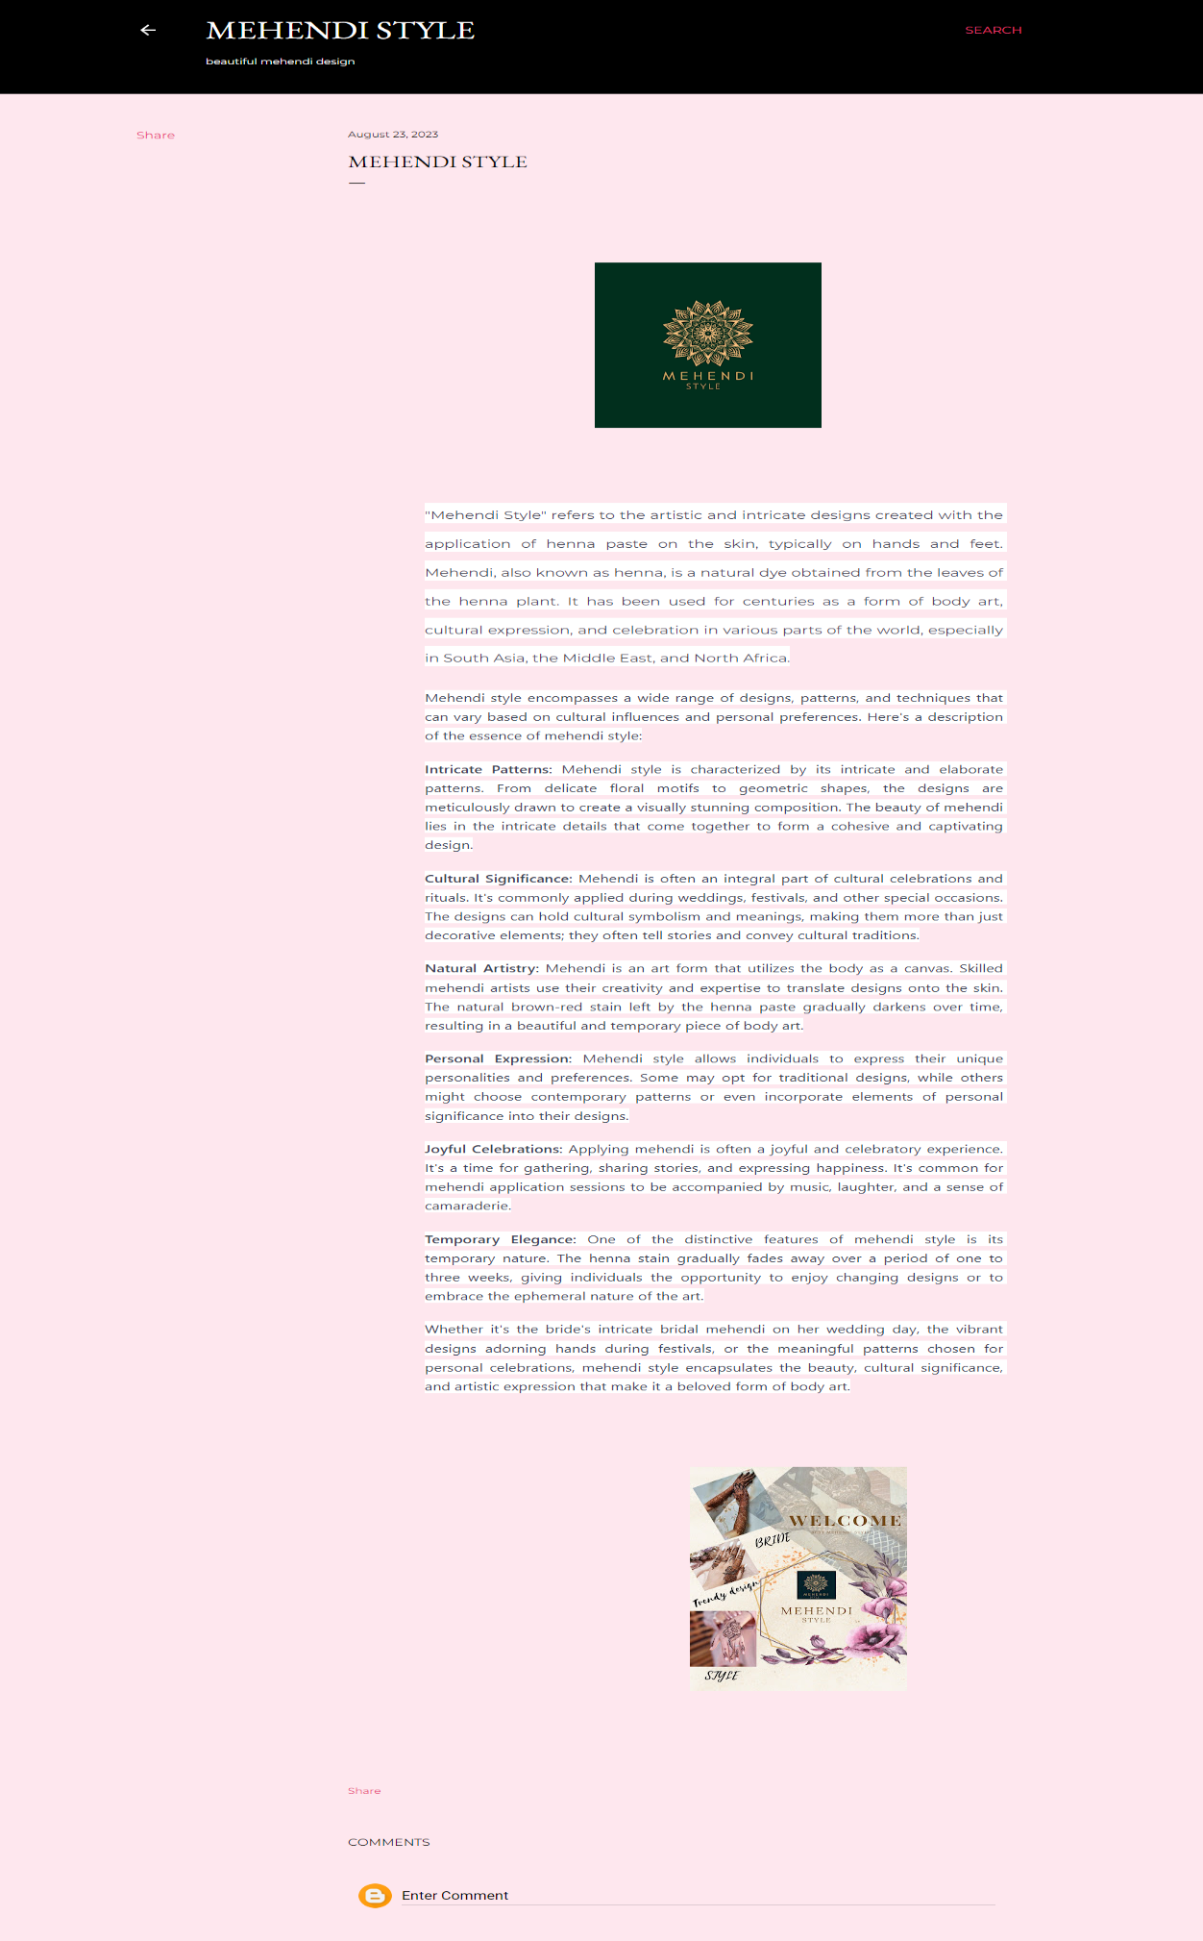

2. Create a New Facebook Business Page and post one social media poster for your brand.

<https://www.facebook.com/mehendistyle4344/>

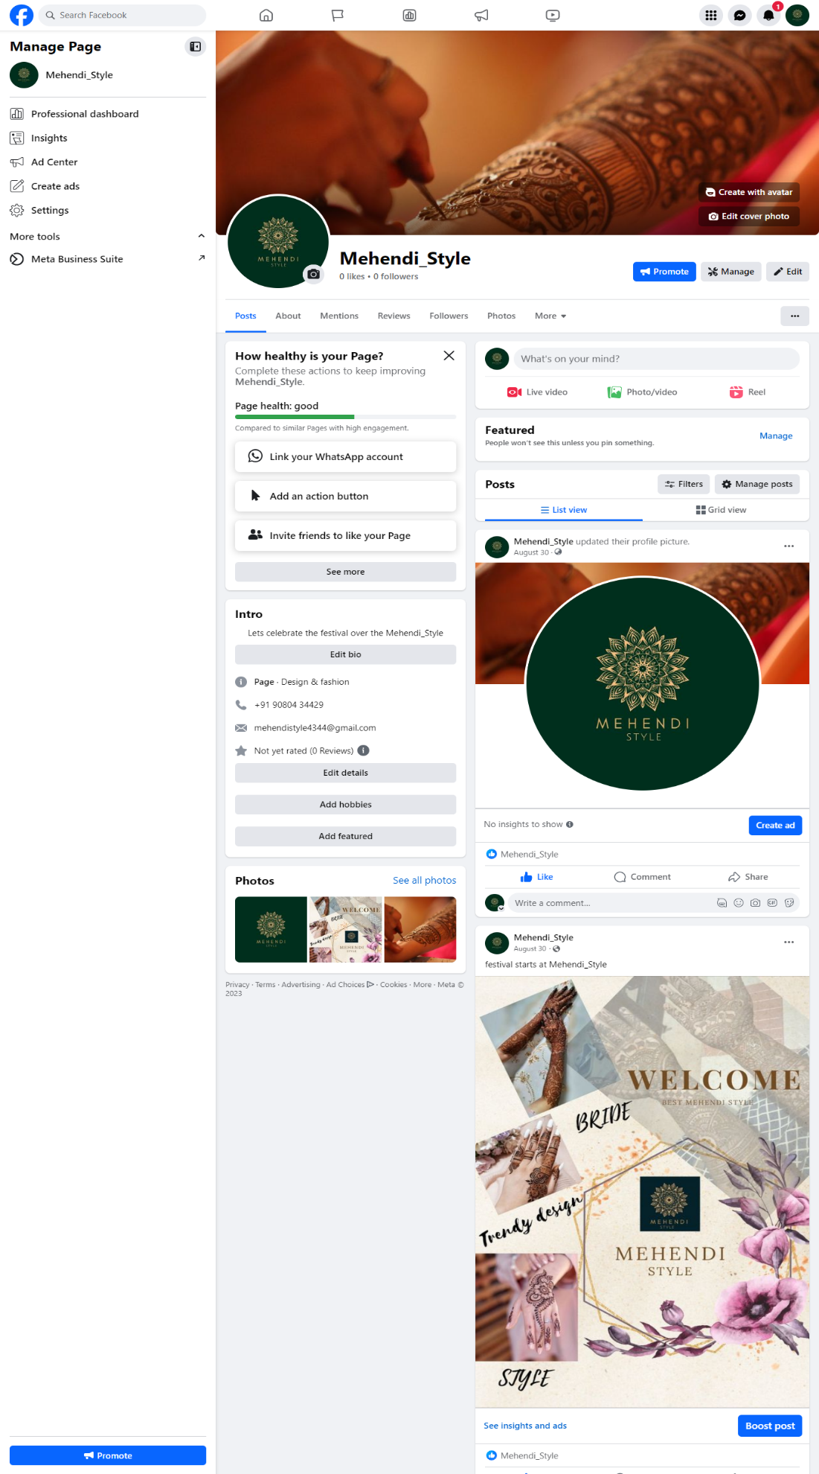

3. Create and design a social media advertisement poster using canva.



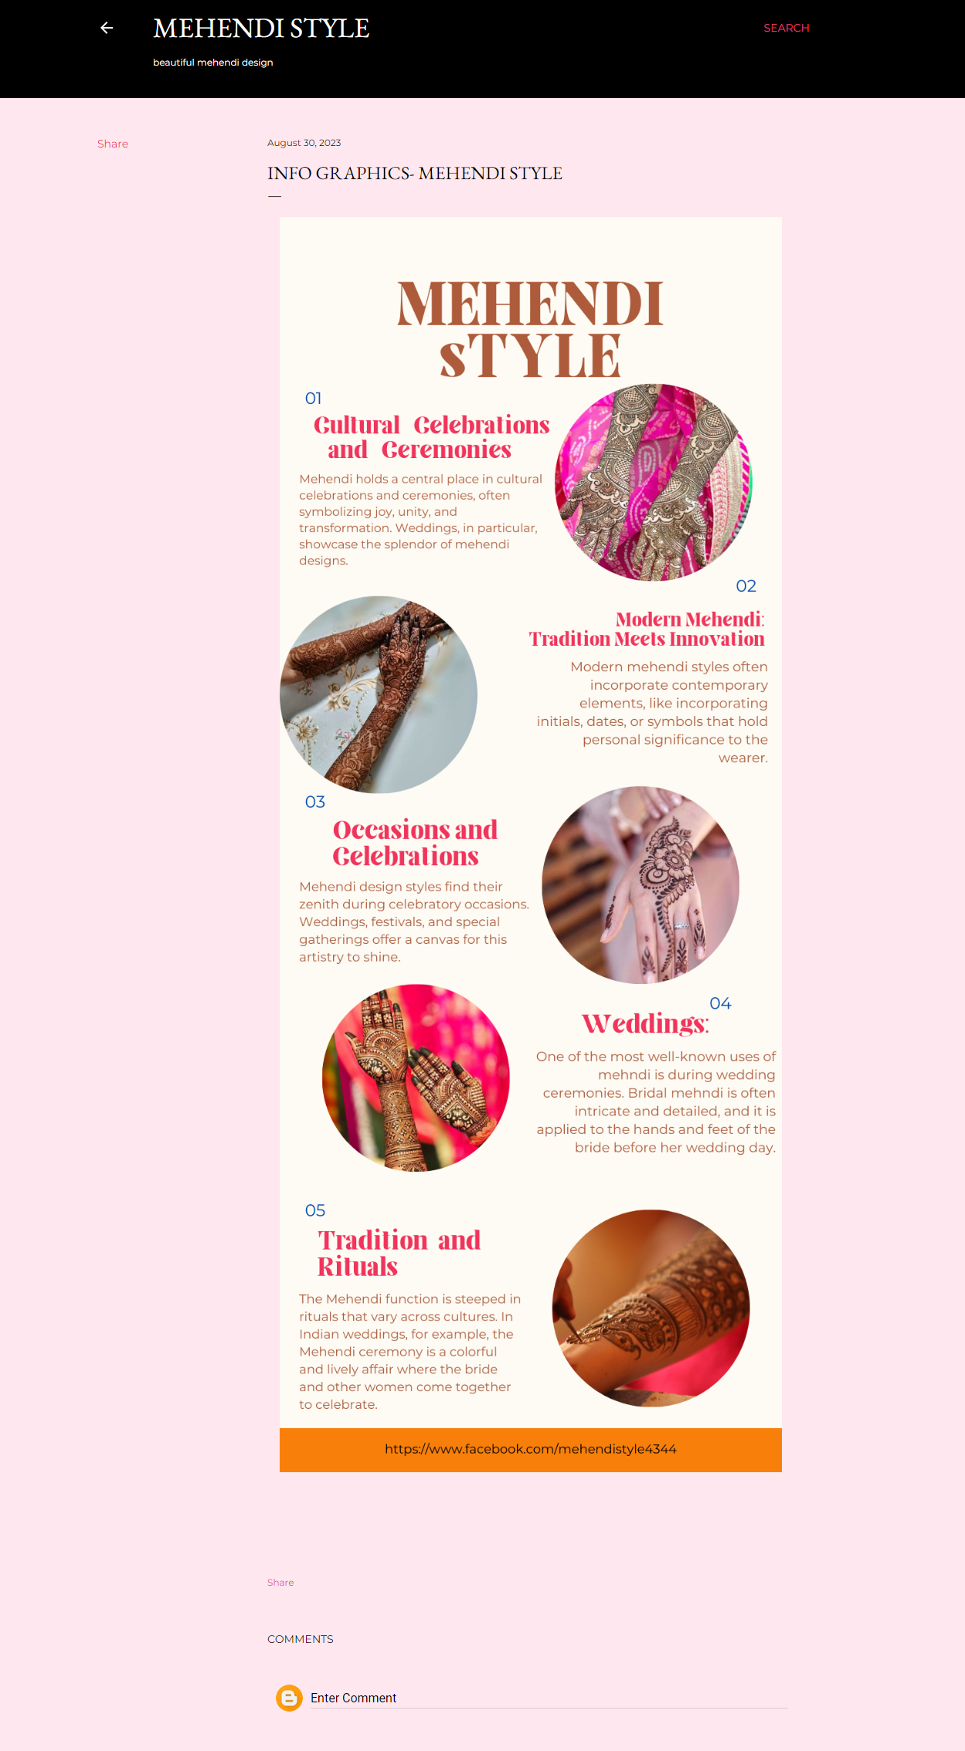

4. Create email newsletter design using MailChimp or canva tool.

